AMANA TRUST DIAGNOSTICS
No 15, Tudun Wada C, Nasarawa LGA, Kano State.
Phone; +2348164093504, +2348033390574
Email; amanatrust2022@gmail.com
11/19/2025 11:18:08 AM
NAME: SAADATU AHMAD | Age: AD | Sex: F | Ref No:000
Clinical Details: USG ABD |  |  |  | US:10

REAL TIME ABDOMINO-PELVIC ULTRASONOGRAPHY EXAM: REVEALED:

LIVER: Normal in size and uniform homogenous echotexture seen. It measured about 134 mm. No surface retraction or nodulations. No definite focal lesion. Intrahepatic biliary radicles are not dilated. Hepatic veins and I.V.C are not congested. Portal vein is not dilated.

GALL BLADDER: Semi-contracted at time of examination. No sizable intra-luminal stone seen. C.B.D is seen patent and not dilated. Wall thickness normal

SPLEEN: Normal in size with normal echo pattern. It measured about 71 mm. No focal lesion seen.
BOTH KIDNEYS: Average size with normal shape and smooth outline. The right kidney measure approximately 114 mm x 46mm while the left kidney measured approximately 113 mm x 38 mm. Normal parenchymal Echogenicity with good CMD. No pelvicalyceal dilatation is seen. No backpressure changes cystic or sizable typical calculi seen.

URINARY BLADDER: Distended with urine with normal mucosal thickness. No gross masses or stone seen.
UTERUS: Anteverted and empty with no evidence of gestation seen, it measured about 35 mm in its AP diameter. No visible pathology is seen.
CUL-DE-SAC: There is mild fluid in posterior cul-de-sac.

IMPRESSION: Normal Aborminal Pelvic Scan, DUB.

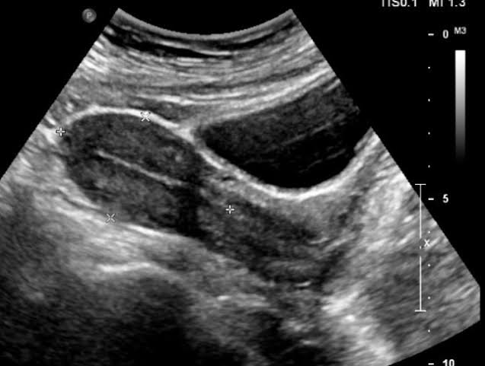 RAD R,A ATIKU
Ultrasound specialist

